Goals Articulation and Process
In this document I state my goals, for beyond my lifetime, for my life, and for my year. Then, I explain the process I used to articulate those goals.

Goals Articulation

What are my Long Term Goals and Visions?
These goals were synthesized from the visioning I did in the process described below. They were written as they are now after the fact.

Seven Generations
- A world safe for all children. A world in which all children everywhere have the opportunity to grow into healthy, whole, adult human beings who are able to contribute to their ecosystem in beautiful and creative ways.

My Lifetime
- Raise at least one child, providing them with an atmosphere of abundance; abundance of love, food, play, connection, natural beauty, and opportunity for learning and growth. Provide this child with the best possible environment in which to grow into a healthy, whole, adult human being.
- What happens after this goal is achieved? An excellent sacred question to meditate on...

What are my goals for this year?
These goals are copied more or less directly from my learning journal, except for two which no longer feel resonant and have been omitted. For more of my thoughts on why I chose these goals, take a look at that learning journal entry. Categories were applied afterwards.

Soul
- Feel confident and secure in my sexual energy and self care, be my own best lover
Sustenance
- Meet my income needs with entrepreneurial projects that serve both me and my community
- Push my edges with money and professionalism, and flex my skills as an entrepreneur
Society
- Build community with men, and learn more about sacred masculinity
- Engage actively and fully with Gaia U, as an ELF, an organizer, a participant, and any other ways I can find

Goals Articulation Process

My process of articulating my goals had three basic stages. In the first, I went alone to a high vista here at Earthaven Ecovillage, the community where I am living, and created a sacred container for myself; a space to look within, connect with the big picture of my life, and clarify my goals for the year. In this container, I used an exercise that I had come up with during the recent Gaia Gathering here at Earthaven in September. I drew a quartered circle with sticks on the ground, and assigned one section of the circle to each of the Four Questions (a commonly used tool in Gaia U).
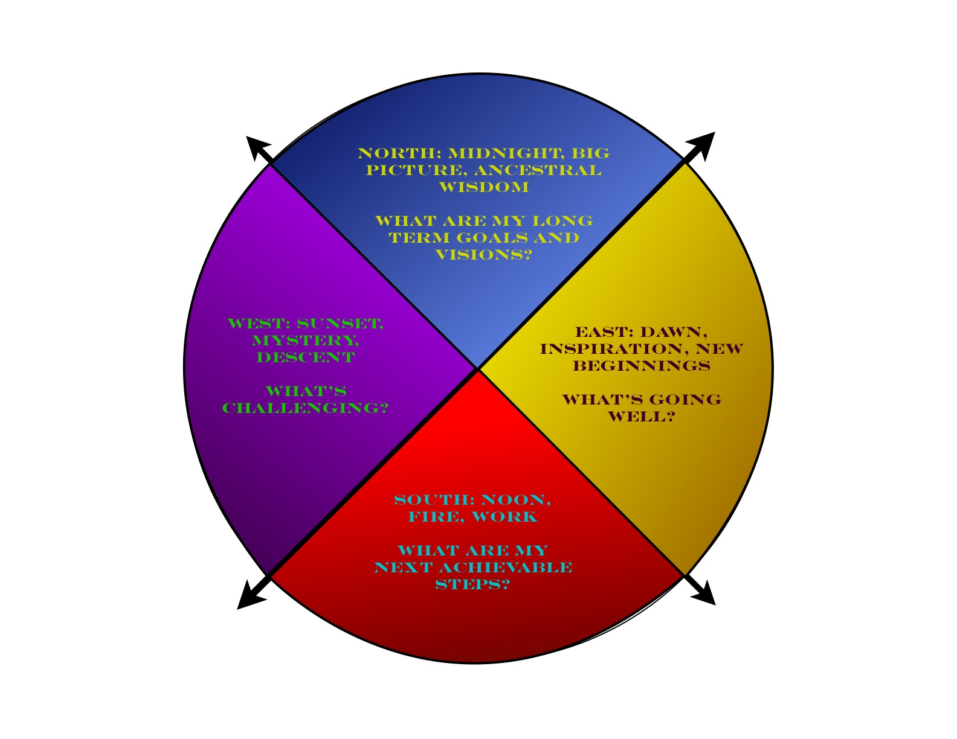

I then stood in each section of the circle in turn, and embodied its question for some time. Standing in the section of “What's going well?” I focused on what was going well in my life, and felt that experience in my body, allowed it to move me. I did the same for each question in turn, moving back and forth and feeling the contrast between them. After I had done this for some time, I stepped out of the circle, went to my journal, and recorded what I had experienced. After some journaling and thinking, I emerged with a clear set of goals for my year.
After coming down off the mountain, I let those goals stew for about a week, while I engaged in some of the next steps I had identified. After that week, I began the second stage, in which I returned to that learning journal entry and began to question and clarify what I had written there. I looked underneath the surface of the goals I had written, and uncovered deeper layers of meaning within them. This dialogue with myself felt powerful and productive, and I discovered a sense of purpose that has been fermenting and brewing throughout much of the last few years, but is only now beginning to come clear. The biggest realization I had was the incredible importance for me of having a child. For the first time, I am starting to claim having a child as a central purpose of my life, as something that I care about more than almost anything else. This gives me a feeling of stability and direction that I have never experienced before.
In the third stage, I synthesized this whole process, and formalized my statement of my goals, both for the year and longer term. In formalizing my goals, I also filled in blanks that had not been addressed in my initial visioning. That stage resulted in this document.

